## Link

## Discussion techniques

## Multiple-Pass Rendering System

Multiple-pass rendering is just rendering the screen multiple times with appling differents shaders to create differenet effects. To do this I just need to render the screen, save the contents of the screen and send that data to be rendered using a different shader

To set up multi-pass rendering, I first rendered the entire screen normally with rendering each object separately with each object using their own defined shaders and textures.

Afterwards I converted the entire screen into a texture to then display. This occurs in the function ScreenToTexure function. The texture is taken from the screen using the glCopyTexImage2D command that simple converts the entire screen into a 2D texture. The texture is then stored in a premade object solely existing the render the screen texture. The object is just a quad that fills the entire screen and have 2 textures assigned.

The final step is just to render the screen quad with the screen texture. This is done by passing the screen quad into the render function while given it a shader to then apply to the texture. The system uses various functions designed to allow for multiple render pass easily, just add ScreenToTexure(window) and then RenderScreenTexture(shaderID) to create another render pass.

//Render first pass of screen using defaul shaders and texture

renderScene();

if (secondPass)

{

//Get the screen as a texture

ScreenToTexure(window);

//Render second pass applying the chosen shader

RenderScreenTexture(RENDER_PASS_SECOND);

}

## Bling-Phong Illumination Shader

The Bling-Phong Illumination (BPI) is a lightening shader that is used to affect an entire envirornemnet, with the setup I have using the multiple-pass rendering, implementing a screen wide shader was simple. As for the actual shader, most of the technique's effects lightening therefore most of the code is fonding in the vertex shader. The bling-phong uses a basic vertex shader with the only main differnce is being in the lighting used. Instead of using the regular light direction, bling-phong uses a halfway direction which is then passed through to a regular diffuse fragment shader. To calculate the halfway direction. To following code is used.

//Calculate halfway dir

vec3 halfwayDir = (lightDir + viewDir);

halfwayDir = normalize(halfwayDir);

After that is calculated the value is passed into a standard fragment shader with halfwayDir used for the light intesnity.

## Instances

Instances is about rendering multiple copies of an object. To do this I need a way of coping objects and storing all that data. To save memory only data that will chance needs to be stored. The position and scale of the objects are stores within its own structure as this is the data that will change between instances.

struct alignas(16) objInstance

{

alignas(16) glm::vec4 pos;

alignas(16) glm::vec3 scale;

objInstance(glm::vec4 pos, glm::vec3 scale)

{

this->pos = pos;

this->scale = scale;

}

};

To store the data, I used a Shader Storage Buffer Object (SSBO). To set up the, I using opengl’s create buffer and and set the size of the buffer. After the data is all setup, I just need to set the objInstance data so that each instance is different.

To enable instande rendering the rendering function was altering by adding two lines.

// render the instance buffer

glBindBufferBase(GL_SHADER_STORAGE_BUFFER, 0, instanceVBO);

Which binds the buffers to the gpu so the shader knows which buffer to use data from. Then the gpu is tolded to render instance of the binded object

glDrawArraysInstanced(GL_TRIANGLES, 0, vertexCount, numInstances);

This informs the gpu which buffer data to use and how many instances to draw. All that is needed then is the alter the vertex shader to allow for instances.

//Setup instance

struct objInstance

{

vec4 pos;

vec3 scale;

};

layout (std430, binding = 0) buffer InstanceBlock

{

objInstance instance[];

};

I setup the shader so it knows what data is within the instance buffer and set a binding to the buffer so the shader can access the data. To use the data, I can just refer to it as instance[gl_InstanceID]. And intgrate the data into the shader program

## Halftone Shader.

The halftone shader is rather complex and broken into several parts. The first part is to divide the screen into sections. Using screen grab as discussed within the multi-pass system and create multiple instants of the screen quad to fill the screen with numerous square sections with divide the screen. This will be achieved using the vertex shader.

Next step is to average the texture colours and create an average colour that will fill the entire square. This can be done using a mean antialiasing technique by getting all the colour values of each neighboring pixels and calculating the average colour value. Then the square will be turned into a circle with the intensities determines the size. This will be achieved using the fragment shader.

# Test Plan

## During Development Tests

All these tests were done during the development process to confirm that the project is working as in tended

### Multi-pass rendering

The following tests shows the multi-pass rendering system being setup and proves that the system is working as intended

First render of screen

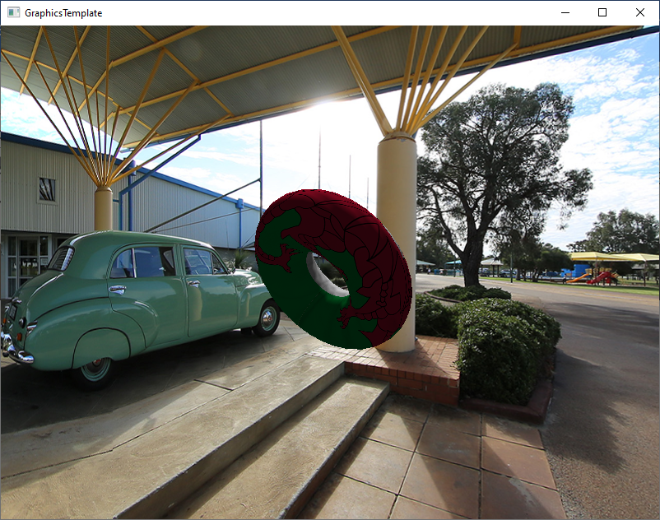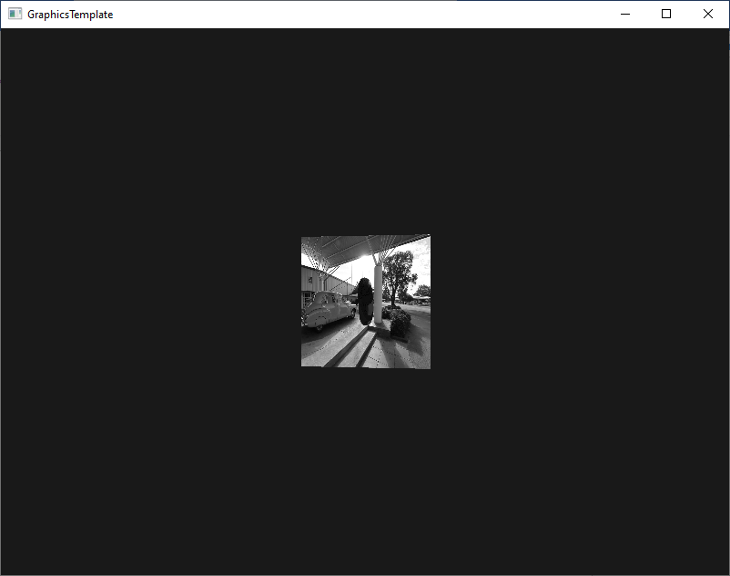

The second screen is rendered using a grayscale shader.

The code is setup up

//Render first pass of screen using defaul shaders and texture

renderScene();

if (secondPass)

{

//Get the screen as a texture

ScreenToTexure();

//Render second pass applying bling-phong shader

RenderScreenTexture(BLING_PHONG_INDEX);

}

The if statement is used to swap between the first rendering and second rendering. This is purely for seeing the different. The grayscale shader is just for demonstrating that the 2nd rendering is working.

The screentToTexture function just converts the backbuffer to a texture mapped to a predined object where the render screen texture renders the object with the attached texture and shaders. By having functions setup like this allows for additional render passes to be created.

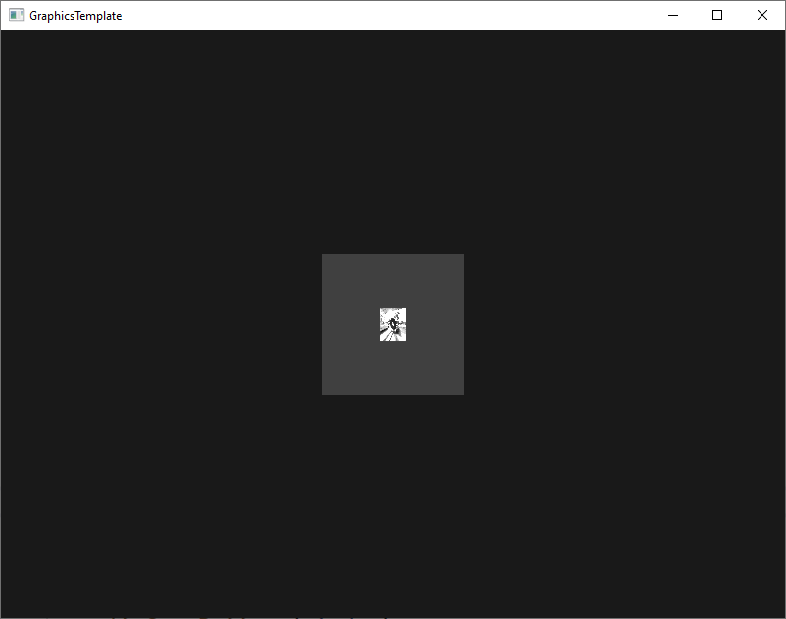

The third pass works, although the shader used just alters the colour like grayscale.

The only problem so far is that the texture isn’t covering the full screen. Other than that, the multi-pass rendering system works

Improved the texture size so the screen texture display much bigger. While not prefect it fully demostrates the multi-pass rendering system.

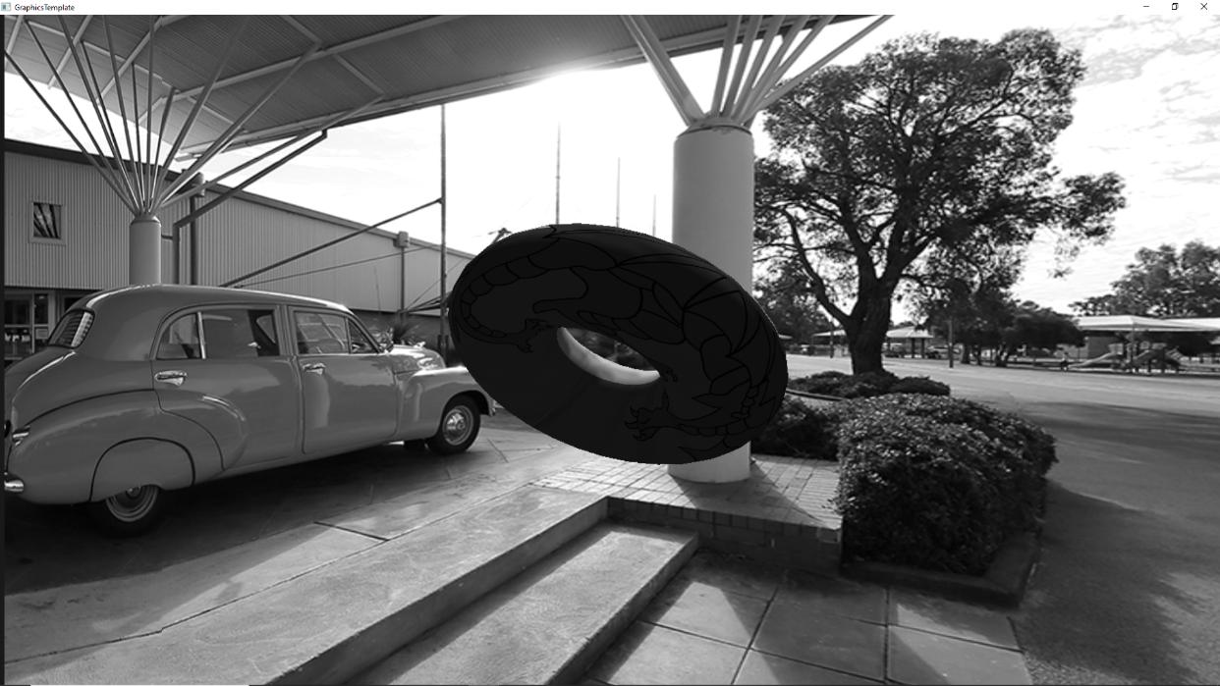

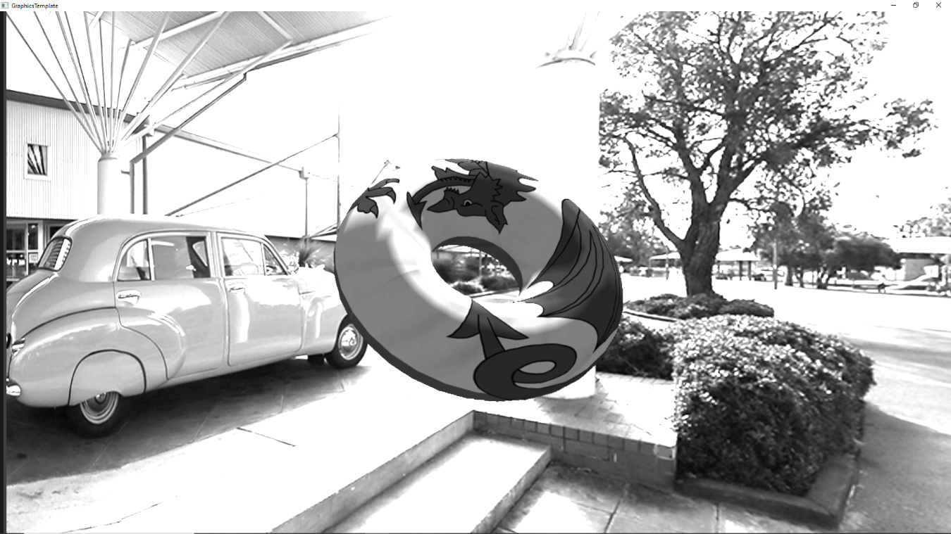

While it may be hard to test the second image is using a third render pass, but it is prove that the system works.

### Multi-texture

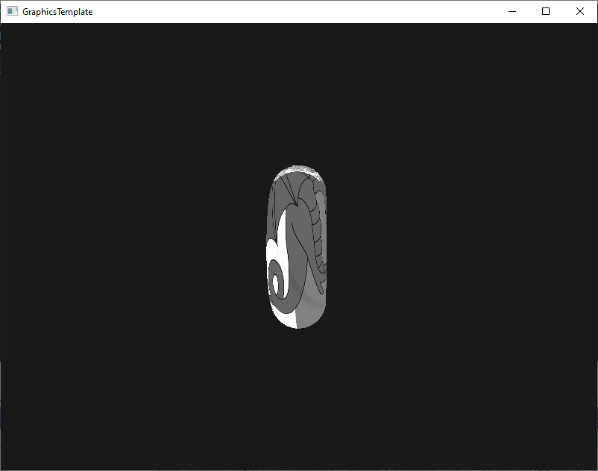

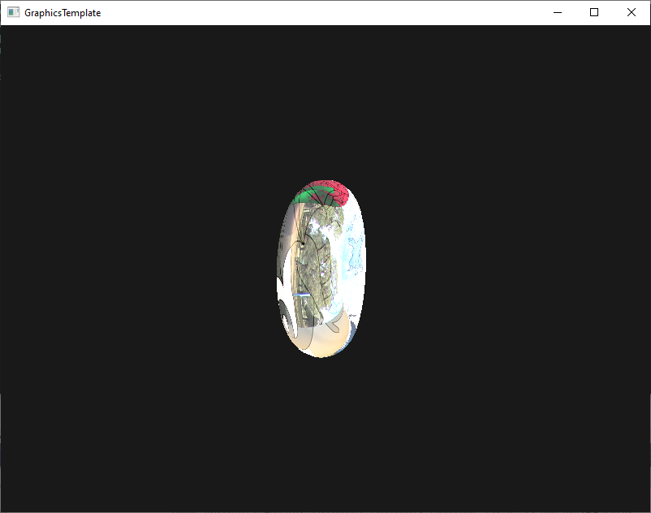

To have mutli-textured object first was adding the texture to the object. This is done by two functions cObject.AddTexture with informs the object that it have a new texture, and CreateScreenTexture. By having these functions allows me to add texture to any object when needed.

## Instance Test

To test instancing I just copied the simple torus object while moving the position of the object.

/ Map buffer and initialise generator

auto instanceArray = (TreeInstance*)glMapNamedBuffer(instanceBuffer, GL_WRITE_ONLY);

// Setup transform for each instance in the mapped buffer / array

for (GLuint i = 0; i < numInstances; ++i) {

instanceArray[i] = TreeInstance(***position and scale data for current instance***);

}

// Once done un-map

glUnmapNamedBuffer(instanceBuffer);

I just infromed the shader then to set the position using the instance

vec4 pos = vec4(vec3(vertexPos.xyz), 1.0) + instance[gl_InstanceID].pos;

And ended up with having multiple instances of the torus object.

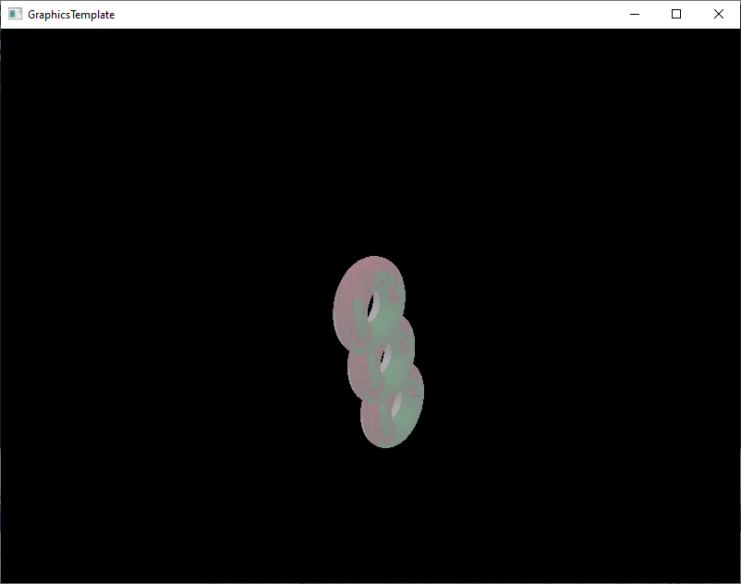

Blinn-Phong

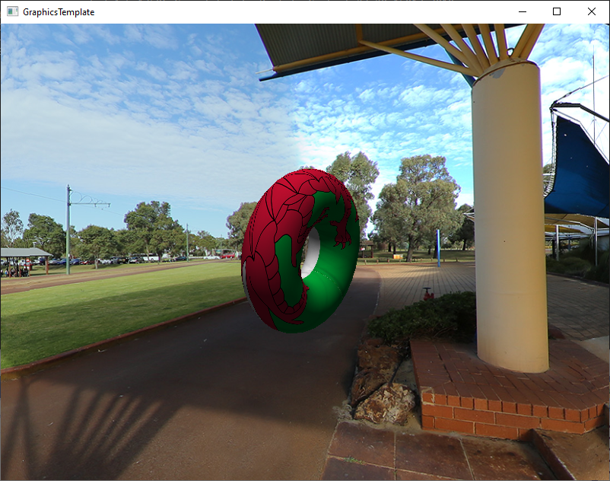

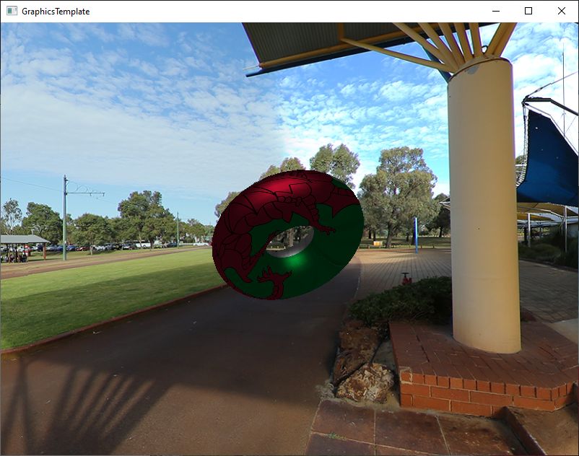

The top photo shows a standard diffuse while the bottom is using the Blinn Phong shader. As seen the lightening is smoother. When applied to full screen the entire scene is much dark, but stills show the lightening.

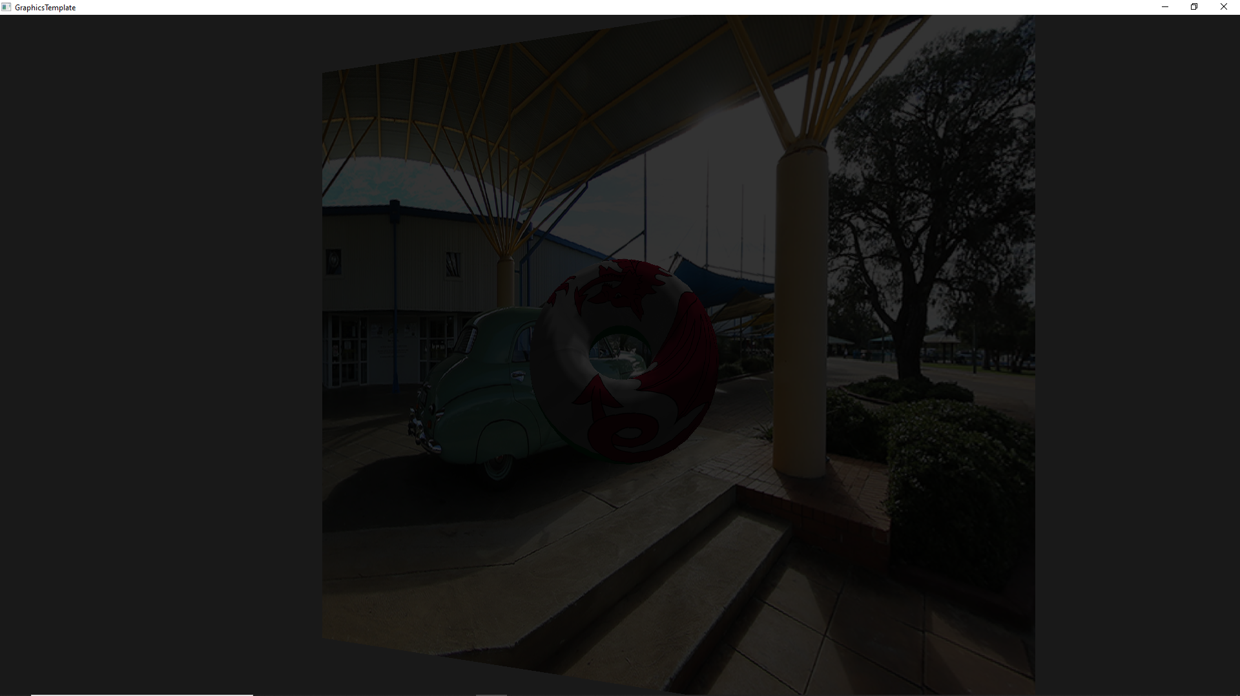

## Halftone Shader

First creating instances of the screen.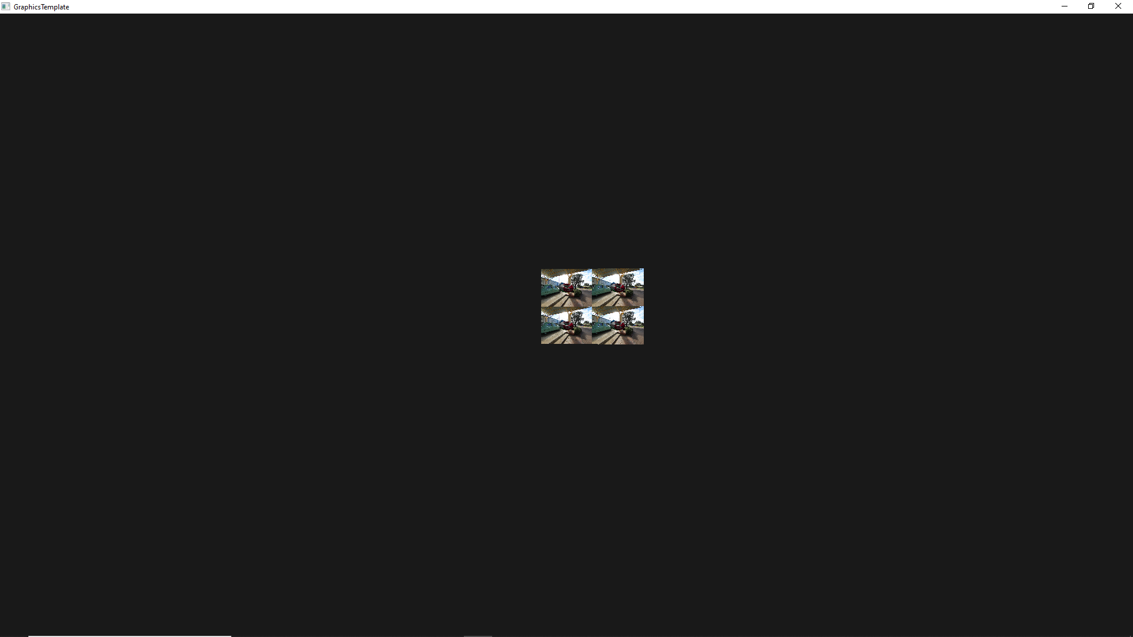

Next create a fill screen full with instances.

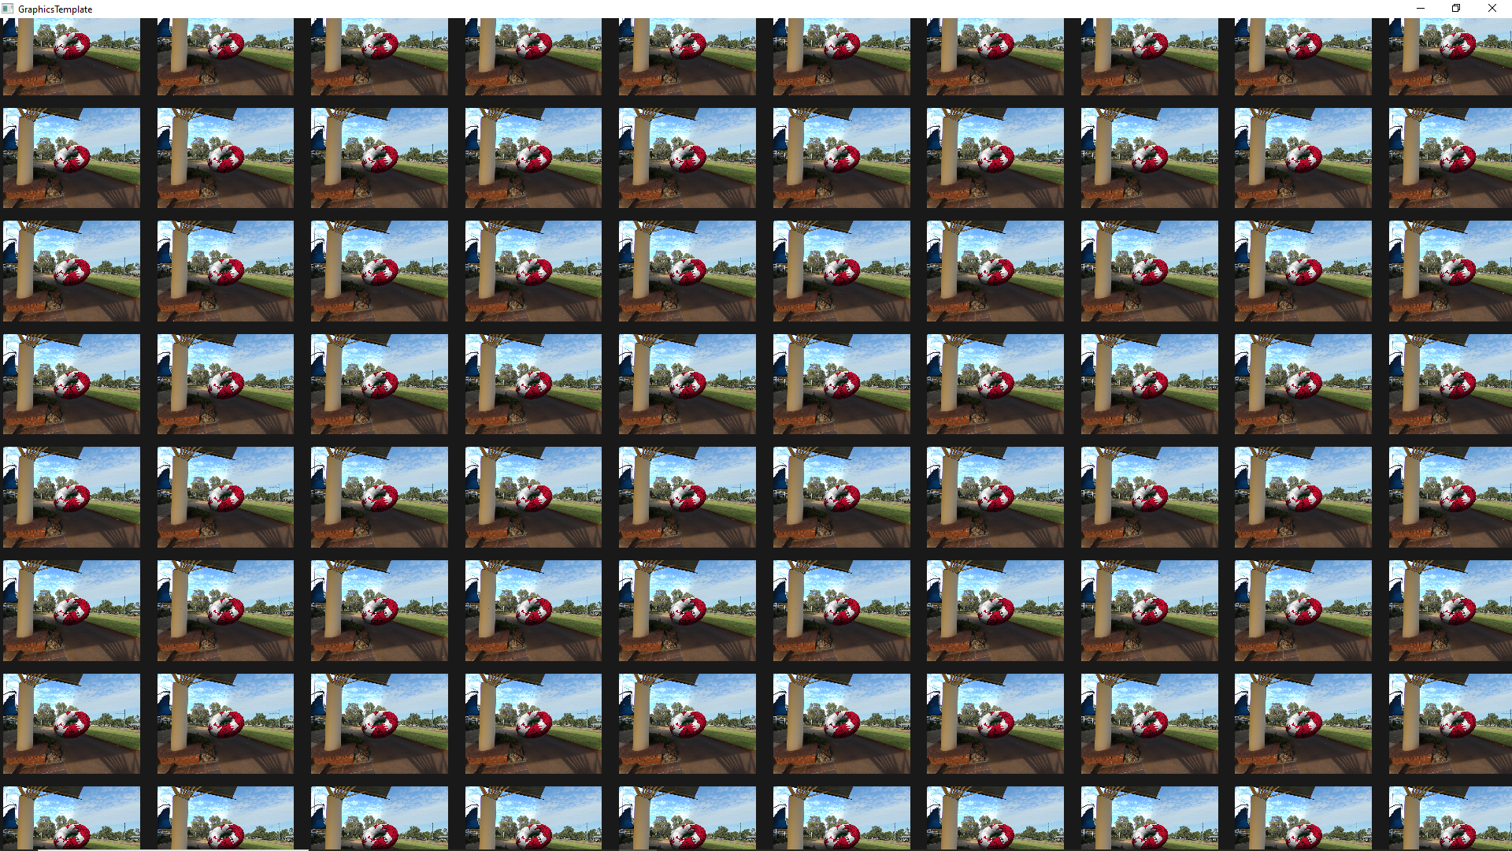

float maxX = 100; //200 2 100

float maxY =100; //200 2 100

float startX = -numInstancesRow;

float startY = -numInstancesColum;

//Calucalte the postional steps

float xStep = float((maxX - startX)/ numInstancesRow);

float yStep = float((maxY - startY)/ numInstancesColum);

//Calulcate size //10 1

float xSize = (10.0f / numInstancesRow);

float ySize = (10.0f / numInstancesColum);

gameObjects[SCREEN_QUAD].scale(vec3(xSize, ySize, 1.0f));

By alltering the position and size of the instances I have fills the screen with instances. Next I need to update the UV coordantes so the isntances contian the UV of the particaluar texture instead of displaying the entire texture scaled down.

## Antialiasing.

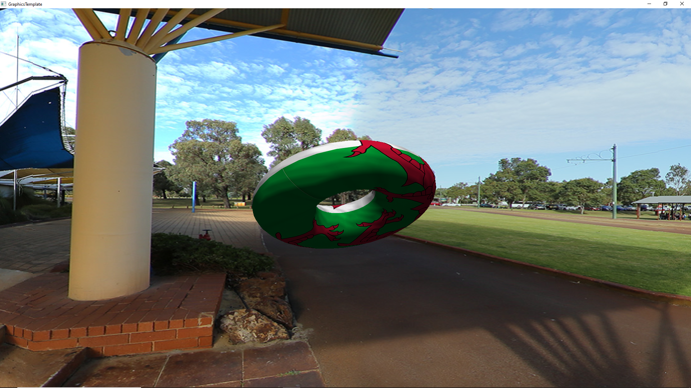

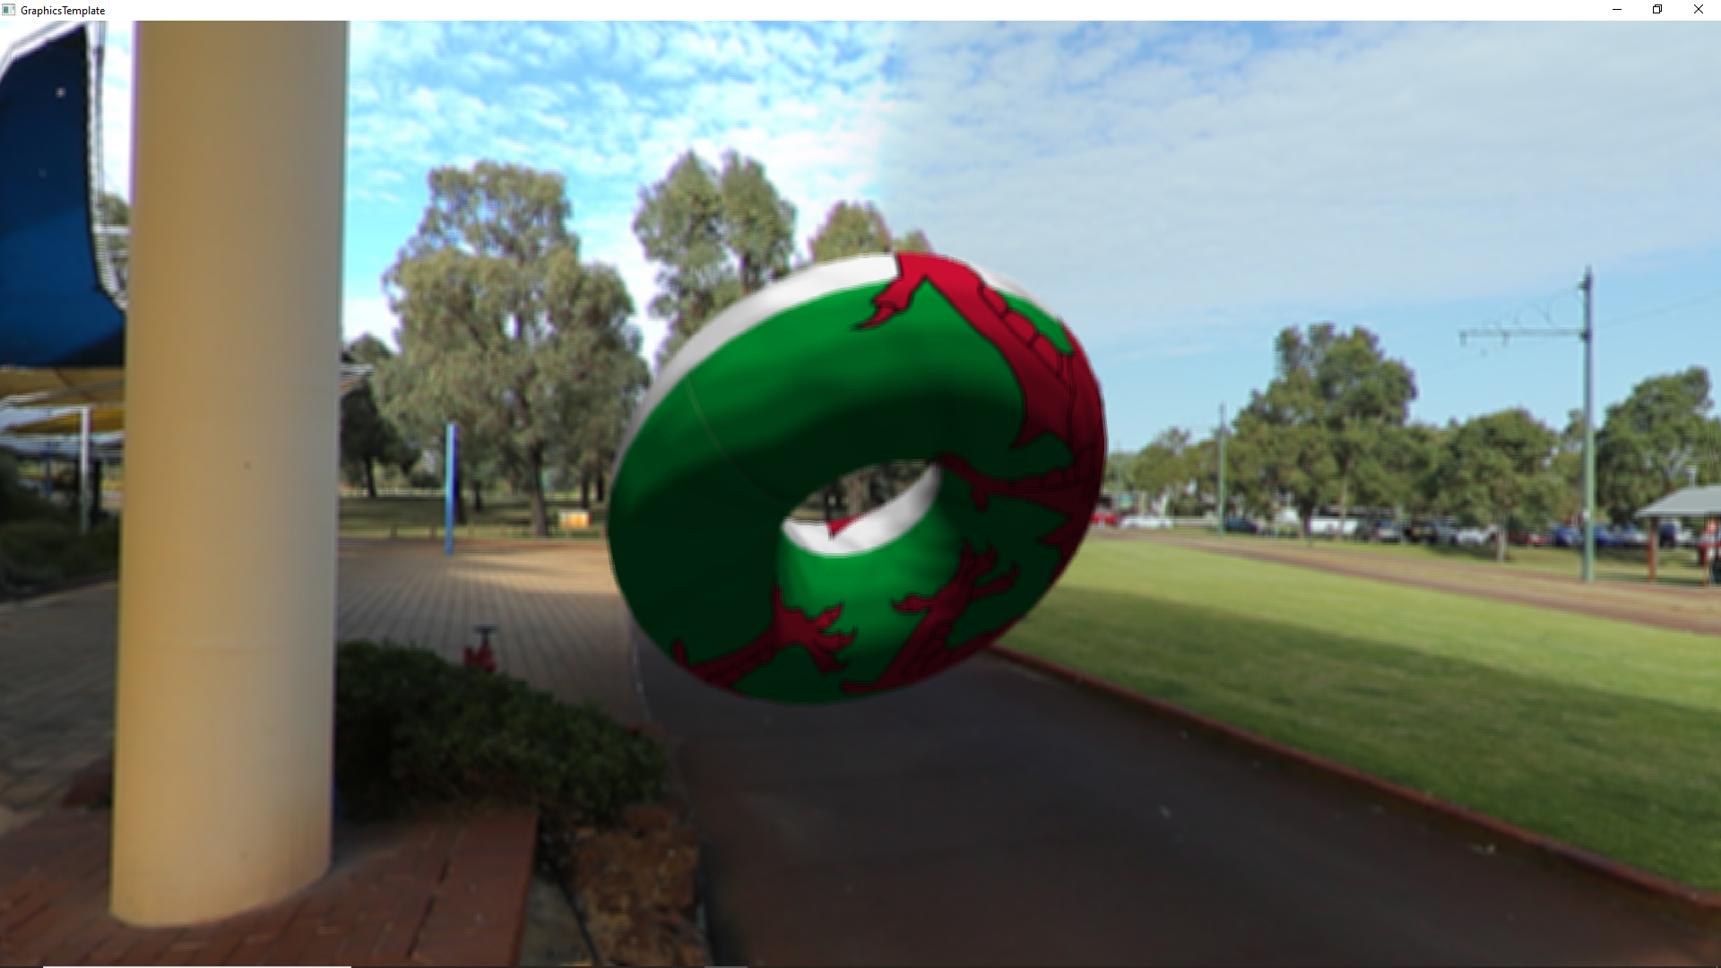

To implement the system.I first need to get all nieghbouring pixels.

This line determines the space between pixels and is used to work out where the next pixel is.

float xD = 1/inData.screenSize.x;

float yD = 1/inData.screenSize.y;

//Nighebouring pixels

pixels[0] = vec2(pixels[4] + vec2(-xD,-yD));

After getting all pixels, I then just calculate the mean of all the values and use that value as the colour value.